A000-Eur-Mycenae-Triad Phi Figurine-1300 -1200 BCE

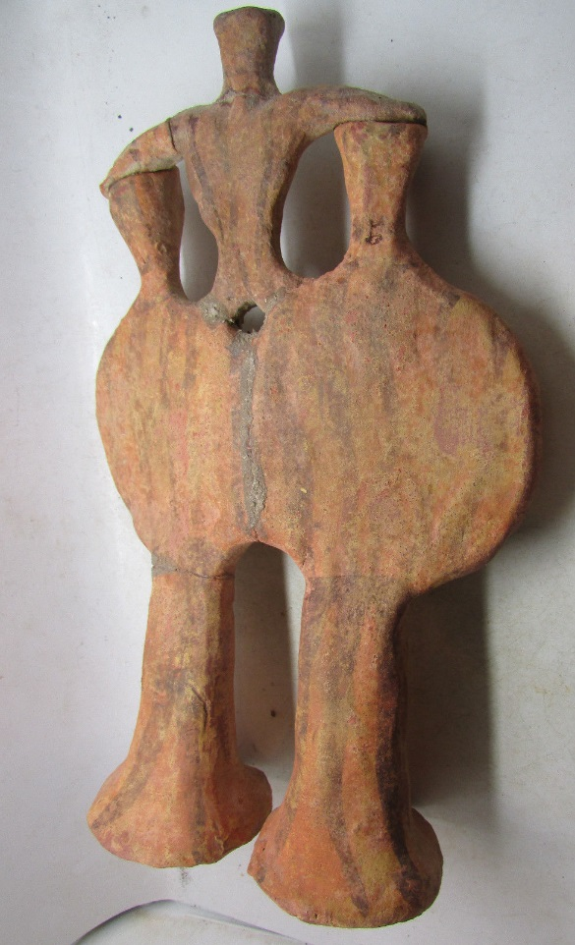 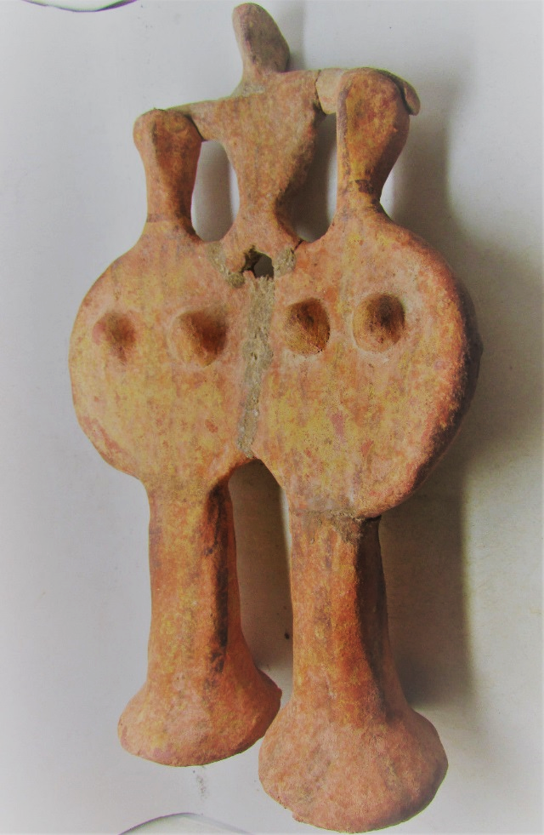

**Case No.: 4**

**Accession No.**

**Formal Label:** Eur-Mycenae-Triad Phi Figurine-1300 -1200 BCE

**Display Description:**

**These figurines, called "phi figurines" for their resemblance to the Greek letter, belong to a series frequently encountered in the Mycenaean art of the fourteenth and thirteenth centuries BC. This group is however distinctive in its rare association of two female figures with a smaller one above. Similar groups have been found in children's graves at Mycenae, which suggests that it may be understood as a divine triad intended to protect the child after death.**

## A Phi Figurine Group

`The group consists of three figurines: two large, joined at the torso, and a third smaller, standing on their shoulders with legs and arms extended and holding on to their heads for support. The clearly visible breasts of the larger figures show that they are women, as do the long tresses and horizontal paint-strokes on their backs. The bodies, modeled by hand, are only schematically rendered. The faces are reminiscent of birds, the ridge of the nose being produced by pinching the clay between thumb and index finger. The arms are not shown as distinct forms, being as it were glued to the body, and thus giving the torso its disk-like form. The legs are reduced to a single column of clay that flares out at the bottom. Such detail as there is comes from the brownish-black painting: the eyes are marked by dots, and the costume rendered by undulating lines.  
On account of their general appearance these figurines have been called "phi figurines," by analogy with the Greek letter of that name.

## A Divine Triad?

The uncommon association of two figurines carrying a smaller third has led to their being identified as kourotrophic divinities, that is, as protectors of children. A number of similar groups have been found in children's graves, at Mycenae in particular. They have been interpreted as two nurturing goddesses protecting the mortal child or infant god they carry on their shoulders. Such offerings were deposited in graves to accompany the child on its journey to the world of the dead, protected by these kourotrophoi.

## A Characteristically Mycenaean Work

These anthropomorphic figures with their schematic forms are characteristic products of the Mycenaean period (1450-1150 BC). They exist in three different forms - "phi," "tau," and "psi" - named for the different positions of the arms. Produced in great numbers, they were the work of potters, as is evidenced by the cylindrical treatment of the lower part of the body. The "phi" type first appeared in the Late Helladic IIIA:2 period (1375-1300 BC), while the "psi" form made its appearance only in the next phase, Late Helladic IIIB (1300-1230 BC). The complexity of the composition suggests that this work was produced in the period of maturity of the phi figurine, between 1300 and 1200 BCE.

**LC Classification:**

**Date or Time Horizon:**

**Geographical Area:**

**Map:**

**GPS coordinates:**

**Cultural Affiliation:**

**Media:**

**Dimensions:**

**Weight:**

**Condition:**

**Provenance:**

**Discussion:**

**References:**